Check-point

Session 3: Array

**Init (after 2)**

Initialize an array named movies containing the titles of some of your favorite movies

**Create (after 4)**

Add new item named newMovie into the end of the movies array you initialized, newMovie entered by users

**Read (after 5)**

Read the item at position i in the movies array, i entered by users

**Update (after 6)**

1. Update the first item of the movies array into movieTitle, movieTitle entered by users
2. Update a item at position i of the movies into movieTitle, i and movieTitle entered by users

**Delete (after 7)**

1. Delete 1 item at position i from movies array movies, i entered by users
2. Delete n item at position i from movies array, i and n entered by users

**Read All (after 10)**

1. Read or log all of items in movies array into console
2. Read or log only first half items in movies array into console
3. Read or log all of items in movies array into console with the item position, for example:

['Batman', 'Up', 'Attack on titans', 'My boss my hero']

when printed out, results as follows:

1. Batman

2. Up

3. Attack on titans

4. My boss my hero

**Update All: (after 11)**

Change all items of movies array into lowercase

**Purpose of While (after 14)**

*Note: If you have not figured out how to check a String length, google to learn about it with the keyword 'JS check String length'*

Write a script asking users their username, if the entered username is too long (>15 characters), tell them that and ask them to re-enter a new username, if the username is short enough (<=15 characters), tell them it is good.

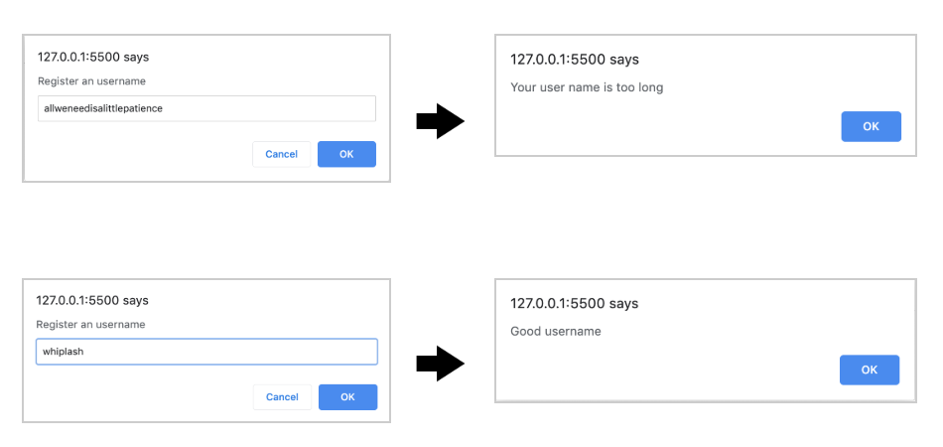

Write a script to show user a quiz with 4 choices, for example:

How many legs does a spider have?

1. None

2. 4 legs

3. 8 legs

4. 12 legs

Then ask them to answer this quiz, if they enter an invalid choice, 'hahaha' for example, tell them it is invalid and ask them to enter their choice again:

Invalide choice, the answer must be 1, 2, 3 or 4

If the choice is valid, check the result, if the answer is not correct:

Good luck next time

If it is:

Bravo, you are correct

-------------------

BT thêm:

Người dùng nhập n số nguyên ngẫu nhiên từ bàn phím.

1. Sắp xếp dãy vừa nhập theo chiều tăng dần
2. Lọc dãy trên thành 2 dãy: dãy chẵn và dãy lẻ
3. Loại bỏ các số trùng nhau ở 2 dãy.